**Assignment -4** Python Programming

|  |  |
| --- | --- |
| Assignment Date | 29-10-2022 |
| Student Name | V.Rakesh |
| Student Roll Number | 110719106035 |
| Maximum Marks | 2 MARKS |

**Question 1:**

**Import the necessary libraries** Solution:

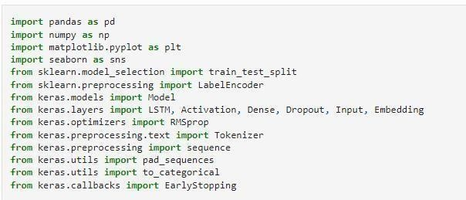

**Question2:**

**Download the Dataset** Solution:

Dataset Downloaded and uploaded to drive [https://www.kaggle.com/code/kredy10/simple-lstm-fortextc](https://www.kaggle.com/code/kredy10/simple-lstm-for-text-classification/data)lassification/data

**Question3:**

**Read dataset and do pre-processing** Solution:

Read dataset



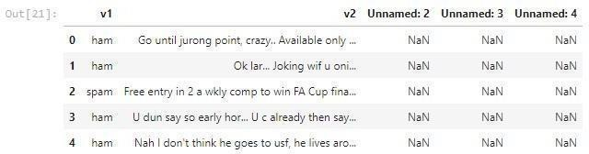

Pre-processing the Dataset

